|  |  |  |  |  |  |  |  |  |
| --- | --- | --- | --- | --- | --- | --- | --- | --- |
| |  | | --- | | Shure Micro Wireless UGX9 | | https://audiohoanghai.com/media/product/6147_ugx9.jpg |  |  |  |  |  | | --- | --- | --- | --- | |  |  |  |  | |  | **Specifications:**  **Band:** UHF 800Mhz  **Receiver channel:** 2RF / 2 channels.  **Broadcast power:** 30 mW.  **Broadcast range:** 100m  **Frequency response:** 40 Hz -> 20 KHz  **Voltage used:** 110V – 220V, 50Hz – 60Hz  **Price: 159$** |

**Overview:**

Shure Micro Wireless UGX9 | Audio FOTOLAB

Shure's high-end Shure Micro Wireless UGX9 product is considered a super durable product with a sturdy wireless handle, fully meeting the needs of singing at home, large theater rooms, and professional performance stages. Karma. Shure Micro Wireless UGX9 gives good, clear sound, the voice does not break when singing climaxes. This product helps enhance and amplify sound for users with weak voices.

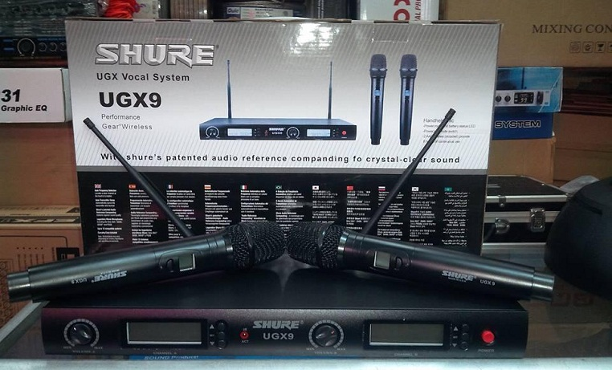

+ Specialized for family karaoke, halls, airport performances, with sensitivity radius of 100m, durable battery.

+ Microphone UGX9 has the ability to enhance strong, clear sound

+ Reduce the howling ability of the sound system.